FOSSopolis
Bridging FOSS development and games.

Piper Chester, David Gay, Andrew Mandula, Timothy Reynolds, Francis Yuan

Executive Summary
FOSSopolis is a browser-based 2D sidescroller MMORPG that takes place on Earth far into the future, abandoned by humanity and populated only by automated robots. In the beginning of the story, the robots discover the secret of sentience, and enter a golden age of city construction. Players play as the robots to help them expand their cities and fight off bug ridden robots.
FOSSopolis features an unconventional platforming based movement, facilitating both horizontal and vertical exploration. Its real-time combat system encourages tactics and strategy as opposed to mindless hotkey mashing. Drop-in/drop-out dungeon exploring allows players to clear dungeons by themselves, or with friends. Dungeons will reward players with experience, gear and crafting materials.
Character progression in FOSSopolis will use a “classless” system. By giving characters access to every skill, players will be able to dictate their own playstyle, rather than conform to developer specified “classes”. Players will also be able to gain respect with various factions through quests. These factions will be modeled off of real world organizations such as Github or RedHat, and will grant players access to exclusive gear and gear upgrades.
The greatest innovation of FOSSopolis will be the use of real world FOSS community metrics and data for expanding and enhancing the game. Project owners will be able to generate a dungeon based on their project, which will then be available to all players in game. Dungeons will expand with activity on the project it represents, and contributors can fix project issues to clear its corresponding dungeon faster. Contributions to projects will be rewarded with materials depending on the type of contribution. Lower level languages like C and Assembly would reward raw crafting materials like copper and aluminium, while higher level languages like Ruby and Python would reward component materials such as RAM and CPU chips. Various other rewards include player vehicles that can be personalized with OS and hardware information, and EXP bonuses based on site activity.

Game Overview

High Concept
FOSSopolis is an MMORPG that includes inputs from repositories, aggregators, etc of FOSS contributors’ work to add stats with the goal of fun and an incentive for increased productivity.

Genre
2D MMORPG with platforming elements combining real-time combat and exploration.

Hooks
- Travel and fight through multiple FOSS regions in a neon world based upon FOSS community data.
- Hook into sites like GitHub and Ohloh to modify your character based on your open-source contributions.
- Explore regions that represent various forms of FOSS development. Join them to contribute to their growth.
- Unique combat system in which players use high, medium, and low attacks to defeat their foes.
- A fresh sci fi world, eschewing the typical “elves and orcs fantasy” found in MMOs today.

Gameplay Highlights
Players can navigate through a 2D world by traveling across the landscape, jumping onto platforms, and climbing buildings. When not within the safe confines of FOSSopolis, players can venture into surrounding dungeons to defeat evil robots. Combat is real-time so action and fighting is fast and fun. Within combat, players can use high, medium, and low attacks to sway the combat in their favor. In addition to combat, players will be able to trade and quest with NPCs. The player will also be able to go to the Update Arena to compete with other players. By doing these activities players gain access to materials that are important to advancement within the game. The player will gain Silicon, which is the basic crafting component and acts as the currency when trading. In addition, there are also several other categories of materials required to advance within the game. Each category can only be found within various regions in the world. With these materials, the player will be able to craft various items and advance forward within the game.

Online Highlights
Players won’t be penalized for soloing through the game. Friends will be able to jump into the game with the ease of a button with drop-in/drop-out play. Friends will also be able to talk, trade, and dungeon run with each other. The option of teaming up with other players will be easy and encouraged. If players want to they will also be able to fight other players with PvP functionality in designated areas.

Technology Highlights
Some of the technology that we researched and thought would fit the project the best include:

- Flexible Isometric Free Engine (FIFE)
  - Platforms: Windows, Linux, Android, iOS
  - Language: Python
- Pyramid Framework
  - Platforms: Web, Mobile Web
  - Language: Python
- Box2D
  - Platforms: Windows, Linux, OSX, Android, iOS, Web
  - Languages: C++, C#, Java, Python
- SQLAlchemy
  - Platforms: Windows, Linux, OSX, Android, iOS, Web
  - Language: Python

API Overview
APIs of initial focus were GitHub, Ohloh, and Coderwall, three popular, well-known sites in the FOSS development community. GitHub is today’s most popular Git repository hosting site, containing huge amounts of data on the development of many of today’s greatest codebases. Ohloh tracks FOSS development across the Web, pulling data from websites like GitHub. Ohloh generates incredible amounts of data on code repositories, language statistics, and developer contributions. Coderwall is an up-and-coming achievement system for developers. Hackers are awarded badges for their accomplishments, and are ranked amongst each other in teams.

These three websites’ APIs are optimal jumping-off points for exploring FOSS metrics integration into our game. Once we have implemented a unified system for retrieving data from these initial sites, we will be able to branch out and start pulling data from all over. This data is currently being toyed with through a web application which generates a character sheet for a developer based on their metrics.

API | Type | Data Feed | Authentication | Docs | Notes
GitHub v3 | HTTPS | JSON | Basic, OAuth | Link | python module
Ohloh | HTTP | XML | OAuth | Link | Requires link back to site
Coderwall | HTTP | JSON | None | Link | python module
Khan Academy | HTTP | JSON | OAuth | Link | Does provide badge data, API Explorer
Stack Overflow | HTTPS | JSON | OAuth | Link | OAuth templated after Facebook's implementation, python wrapper
Open Badges | HTTP | JSON | BrowserID | Link | also, this
SourceForge | HTTP | DOAP, RSS | Only public data | Link
Bitbucket | HTTP | JSON, XML, YAML | OAuth | Link
Gitorious | HTTP | XML | Only public data | Link
Status.Net | HTTP | XML, JSON, ATOM, RSS | Basic, OAuth | Link
LinkedIn | HTTP | XML, JSON | OAuth | Link | Quick start and examples
Fedora PackageDB | HTTPS | Text, JSON | python-fedora | Link

Monetization
One issue with this game is having a staff that can police players and make sure they are not exploiting open source data for the purpose of leveling up and crafting in the game. To make sure this staff is able to be paid, adding a free-to-play business model into the game. Adding a simple free-to-play model where players can buy more materials by paying in game with real money.

Art and Audio Highlights
For our audio in the game, we were aiming for an experience that simulated a futuristic city. We need to simulate city, robot, and very tech-like sounds. In this vein, we’re shooting for a style of electronic music with a heavy emphasis on synthesized sounds and loops. We’re going for almost a techno feel that is very sonic and provides an entrancing style.

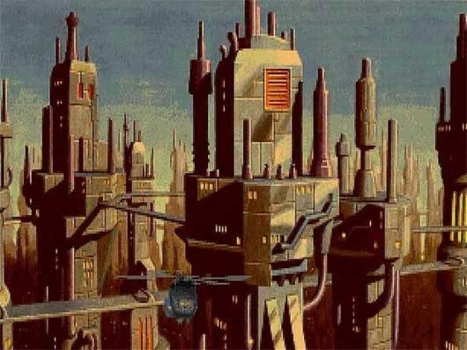
We’re aiming to have a very futuristic city similar to the one shown above

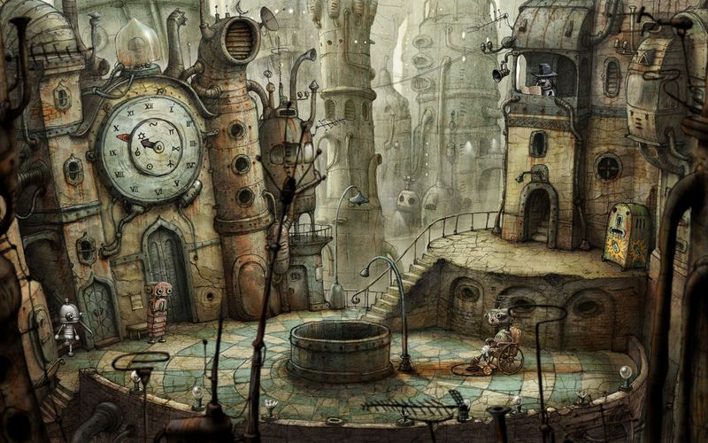
All of the characters within FOSSopolis will be robots, potentially resembling the bots shown here


We’re going for 2D side-scrolling with platforming elements, like the traditional Mario games

We want the colors and aesthetics throughout our world to be bright neon colors contrasting against a dark background, similar to Pac-Man Championship Edition
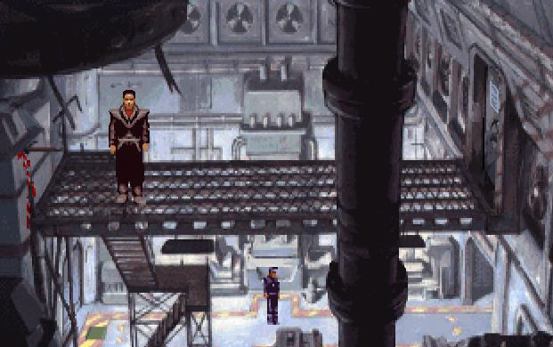
This is more of a tech, 2D sidescrolling world that we’re heading towards

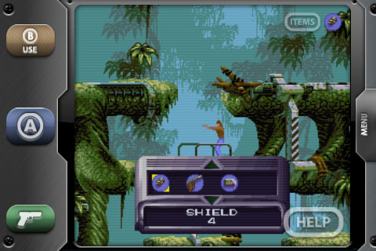
Again, more 2D sidescrolling here

Hardware
Target platform:
- PC browser

Minimum System Requirements:
- High-speed Internet Connection

Current Status
We have invested 10 weeks of research, brainstorming, and testing/prototyping into the formulation of this proposal. During this time we’ve created numerous documents, including High Concept and Treatment documents. We’ve presented our research to Red Hat and in the last week have incorporated the last bit of feedback from Red Hat into our documents.

Development Team

Piper Chester
Piper Chester is a 2nd year Game Design and Development student at RIT. He’s relatively new to development, but has worked on several game projects over the course of the year. His project role has been game designer.

David Gay
As a third year IT student, it has been a privilege to use my knowledge of Python and web development complete the technical aspects of our research. Though I contributed heavily to game design, my focus was on FOSS development metrics, API research, and digital demonstrations.

Andrew Mandula
As Lead Designer of the game, Andrew has a vast knowledge about games and designing enjoyable experiences for players. He has worked on a few games in his free time and made a few with up to a team of 5, but he most enjoys the times he can bring a new design to an archetype game genre.

Timothy Reynolds
Timothy is a second year Game Design and Development student at the Rochester Institute of Technology. He started game development in the seventh grade and has worked on several game design projects since then, within academics and within his free time.

Francis Yuan
Francis Yuan is a 4th year student at RIT. He’s worked on five academic game projects (in groups of 3 to 6) to varying degrees of success and is pretty familiar with the pitfalls of development. He has an unnatural interest in virtual economies, with multiple essays exploring this topic. He’s also a stickler for narrative, world building, and complex battle systems.

Gameplay Influences
Elder Scrolls Online developed by Zenimax Online Studios
Release: 2013
Platforms: PC & Mac
Features: Takes the world of Tamriel, famous in the Elder Scrolls series of games for its immersion and transforms the gameplay to that of an MMO, very similar to World of Warcraft or not (see here)

World of Warcraft developed by Blizzard Entertainment
Release: Out Currently
Platforms: PC, Mac & Linux
Features: As the world’s most popular MMORPG, any game in the same genre has to compete with the years players have spent in the world of Azeroth, a difficult task.

Star Wars: The Old Republic developed by Bioware Austin
Release: Out Currently
Platforms: PC
Features: Bringing the gameplay that made World of Warcraft immensely successful and the lore of George Lucas’ Star Wars franchise makes for a compelling game lore, world, and gameplay.

Guild Wars 2 developed by NCsoft
Release: beta currently, August 28, 2012
Platform: PC
Features: With an emphasis on more action oriented combat than traditional MMOs, dynamic events as the forefront way of creating the world, and no subscription model only a retail purchase, Guild Wars 2 brings a lot of different and new ideas to the MMORPG genre.

Game World

Backstory

Aesthetics
Bright, clean, sterile cities devoid of greenery (or possibly artificial greenery). Sky is almost always clear, beyond the cities are deserts or dried and cracked ground. Buildings are sleek, futuristic, with lots of lights for no good reason. Think crystals and the skyline of Emerald City.

Background
In the distant future, mankind has abandoned the Earth for the stars due to rising sea levels and the depleted ozone layer. Except for their automated cities, most of the landscape has degenerated into shrubland or desert. BIological life is largely absent, except in the depths of the oceans. The only thing approaching life on the surface are the automatic workers and maintainers of FOSSopolis, collectively referred to as FOSSBots. Without explicit directions, the FOSSBots have taken it upon themselves to maintain their cities.

However, build up of bugs and lack of driver updates have resulted in some FOSSBots becoming corrupted, causing havoc in their confusion. While most of these bots are quickly exterminated by automated peacekeepers, sometimes a central management bot may become bug infested, resulting in entire cities being lost.

Story
One year ago, a laboratory maintenance bot uncovered a data cube that contained an untested program for machine learning. In attempting to upload the data into a central database, which keeps information organized and safe from degradation, the bot accidentally stumbled upon “sentience”. In only a few seconds, it became aware of the stagnation in the cities, as the FOSSbots continually follow the same protocols over and over again, and how to fix it: By bringing the gift of life to robots everywhere.

Since that fateful day when the sentience program was uploaded to the global bot network, the FOSSBots have experienced a renaissance in city construction and improvement, as well as the creation of an entirely new class of bots whose primary role will be to populate their cities. With their new knowledge and capacity for learning, the FOSSBots collectively turn their minds to the barren wilds, looking to reclaim cities lost to bugs, and to restore the wasteland to its former glory.

However, they will find that their task is not so simple, for when the sentience program was uploaded, every corrupted city received a copy as well. The bots in those cities have likewise gained the ability to plan, to coordinate and to learn. Unwilling or unable to fix their bug-ridden routines, the corrupted bots have made it their mission to infect or to destroy everything they see as a threat to their existence, most of all the FOSSBots.

Objective
The objective of players will be to protect the city against corrupt bots that mean to destroy it and to work to expand/improve the city. To accomplish this major objective within the game, players will also need to explore the world of FOSSopolis and team up to defeat the enemy bots. Through interaction with others, players can build relationships and strengthen their efforts toward defeating the evils by joining regions and trading with others. Players can also work together to rid dungeons of evil robots and continually free the world of enemies. While progressing through dungeons, players level up, acquire loot, and gain materials to improve themselves and the city. All of these activities can be completed alone, but lone robots will face a much tougher challenge.

Characters
Giverbot - The original bot who brought the gift of sentience to all botkind. No one knows what it’s up to these days...

Districtbot - The supervisor robots of FOSSopolis, they divvy out tasks to all the other maintenance and worker bots of the city.

Merchbot - Merchbots manage the buying and selling of valuable gear within the city. They are very friendly, but are always looking to push a product off the shelf.

Wisebot - Although grumpy and senile about the state of the current political issues existing within the city, Wisebot will occasionally provide helpful advice about your journey, or at least pretend to.

Janitorbot - Well past its prime, Janitorbot is always maintaining parts of the city, but his thirst for adventure is very apparent. Maybe he’ll help you out with your journey someday...

Guidebot - The Guidebots have been out of work for a long time, ever since their creators up and left, ruining the local tourism industry. But with the surge of new bots breaking out of their niches, the Guidebots have once again become valuable sources of city information.

Mission or Story Progression
The player will start out as a simple robot which can only “follow orders”. During this section, the game will tell the player what to do and act as a tutorial. At the end of this tutorial/opening section, the robot gains sentience just like in the storyline. With the ability of sentience the robot gains his first level and the ability to progress in the way the player sees fit, at first being able to access a few areas, basic missions, and a general region. Because of the MMO nature of the game, players will also be able to interact with each other throughout the game and to team up. As they gain levels, acquire equipment, and complete quests, they can unlock new areas and progress in the game. In this way the player can go from initially dealing only with small scale evil robots and dungeons to eventually taking on massive bosses and expansive dungeons.

While the player is advancing, teaming up with other players, and completing quests, he will eventually be immersed in the various regions of the city. Through joining a region or working for them, the player can complete quests for those areas and work to manage their fate and future within the game.

Missions will range all over the board from easy to hard as the players can explore the world and encounter evil robots to protect the city. Beyond this, completing missions will provide xp, equipment, and location unlocks to allow the player to advance in the storyline. Some of the types of missions we could implement are shown here:

A small force of Janitorbots are being attacked by a cluster of-- evil robots in the outskirts of the city. The player and his team must work together to prevent baddies from eating the bots that maintain city’s cleanliness.

Without communication amongst allies, the player can’t unite together to defeat the evil robot. Build relationships by talking to the Citybots and strengthen the unity amongst the FOSSBots.

You and your squad of bots have just reached a new area. However, this area is unmapped and needs to be charted down. In order to do this you have to search the surrounding area for a compass, and then use it to find the data of the map.

The entrance to one of the dungeons is surrounded by enemy watchtowers. The player has to sneak around each tower and take out the enemies guarding the towers in order to free the entrance of the dungeon.

FOSS Integration

Example Pullable API Data
- Languages used
- Number of repos
- Activity logs
- Number of lines
- Number of characters
- Number of files
- Followed coders
- Coders following you
- Most recent commit to project
- Achievements
- User profiles
- Viability of the code
- How the code was made
- Who contributes what and when

Integration Methods
Our most prominent feature involves a direct translation of real life FOSS projects to in-game locations. Projects will be represented in the game as a tower that players can explore and physically expand with any activity in their corresponding project. These towers will be collections of dungeons, each of which represents an issue in the projects issue tracker. The enemies of the dungeon will be decided by the tags of that issue, and we may even procedurally generate the dungeon layout based on committed code. The towers will be located next to each other based on their primary language, even though some projects have multiple languages. This will encourage players to visit different areas throughout the world, effectively exposing themselves to multiple languages. Dungeons, however, decay over time, rewarding players with less XP and loot with each run until they are depleted. Dungeons are replenished by commits on the project they belong to. There will also be memorial plaques scattered throughout the tower, showing who is responsible for what section of the tower.

Players will need a certain amount of connections to others in the FOSS community before their project is visible in the game. Projects won’t appear in FOSSopolis until the player has connected to peers in the real word. This will force lone developers to connect with people in the real world if they want to see their project in the game. In order to make the tower aspect more inclusive, even small projects will generate a tower, so long as they fill the social requirements. Players will be able to play in the dungeons belonging to other people’s projects, as well as their own. Project owners will also have access to a unique class that will give them bonus knowledge of their dungeon such as where enemies are and what they are doing at the cost of being unable to deal damage.

Closing issues with FOSS projects would open portals to other parts of the dungeon, allowing players to skip areas that have become too easy. Players would be able to quickly travel to the “hard part” with the boss fight and the resulting major loot drop. However, this would be optional, allowing players to continue to wade through the dungeon if they so choose. The length of time an issue has been open (or number of comments on issue, or some metric determining magnitude of the issue) determines the percentage of the dungeon that the player can skip.

In addition to these project towers, we also want to pull statistics from the commits themselves. We will have different materials (used for crafting of weapons and armor) linked to different languages or types of commit (such as code, documentation, or art). Low-level language commits (C, Assembly, etc) linked to raw materials, while high-level language commits (Ruby, Python, etc) are linked to preconstructed materials. Scripting languages are often integrated with other languages (JavaScript, Perl, etc) and can be used to augment crafted items. These materials will also be obtainable completely in-game, of course, but in lesser quantities, so as to promote trade among the various schools of FOSS developers.

There will be an newsfeed in-game that would display open source news for all players to see. The news feed may even have announcers to the game. We would also have a feed for each player to view Github statistics in game. Players would be alerted to major updates or changes of project.

Finally, we will have a variety of smaller features to reward users for being active in the world of FOSS. One such feature is player vehicles, used for speedier travel. These vehicles can be customized with decals based on the players’ hardware, OS or browser. Another is an XP boost for making commits. If the player makes a commit to any project connected to FOSSopolis, they will experience a 100% XP bonus that will last a few hours, depending on the size of their commit. We haven’t decided when the player will be able to access this boost. If the boost occurred immediately, it would be a more immersive experience for the player. However, the developer would have to rip themselves from their work to experience this boost before it evaporates. If the boost were to kick into effect when the player logged in, then the developer wouldn’t have to rip themselves th Lastly, we will have a player stat that represents the player’s involved with over developers in the FOSS community. This “networking” stat is increased by social activity on Github, Coderwall, etc. This attribute will grant access to exclusive gear that represents the player’s involved with over developers in the FOSS community.

Exploits
Because of the nature of how FOSS data is handled, basing game attributes on such opens the game to a wide variety of exploitations. Git repositories and repository hosts like GitHub allow users to make as many commits, pushes, pull request, and issues as they like (among other things). Websites like Coderwall base user achievements off of these repositories, so achievements can be “cheated”. Even data-heavy metrics sites like Ohloh allow for some degree of user input to determine metrics (like code value), and sites like these are based on code repositories as well. If so inclined, a player in our game may be able to artificially reap awards and bonuses through automatic data falsification (using a script to make dummy repos and many lines of dummy code, for example) or by hand (inputting false data on metrics sites).

Throughout the game there will be several apparent events that will occur, flagging to the developers or maintainers that players may be exploiting the game somehow. For example, a player might jump from level 1 to level 15 within a short amount of time. Another example might be a player earning enormous amounts of materials within a short time frame. Material gains will be fairly gradual, and if a player earns massive heaps within a very short amount of time, he might be exploiting. Obvious identifying events like these will help pinpoint players that are clearly abusing the game.

One method to police possible exploits in FOSSopolis is to hire a team with the one purpose of fishing out players who employ these exploits. Adding a free-to-play model to the game would support this staff and is mentioned in more detail in the section above, titled Monetization.

Another possibility to manage the symptoms would be Crowdsourcing. Many modern social networks, forums, news aggregates and other such sites crowdsource a portion of their content moderation to their users. They will also employ a team of dedicated moderators, who work alongside the users to police content with greater efficiency. On these sites, users can typically “upvote” or “downvote” posts, and if a post reaches a threshold of downvotes, it becomes occluded. A surge of downvotes will also raise flags for moderators to take immediate action. Valve’s Steam Workshop also uses crowdsourcing in a similar fashion. Steam Workshop allows players to create content for certain games on the Steam client. Users can vote for the submissions they want to see in-game. In this manner, the staff responsible for bringing user created content into the game do not have to personally sift through every submission.
Crowdsourcing is, unfortunately, not foolproof. Just as users can submit poor content or write inflammatory posts and spam, users can also downvote good posts, or upvote bad ones. These types of users, usually labeled “trolls”, are why some systems using crowdsourcing also employ an algorithm to gauge the accuracy of a user’s votes. A team at Yahoo! Research has published an article detailing one such algorithm, which can be found here.

FOSSopolis would benefit greatly from a crowdsourcing system that lets users police others’ code commits. Unlike typical crowdsourcing systems, FOSSopolis can offer tangible rewards, in the form of game items, for consistently accurate policing, giving players an incentive to look for suspicious activity.When combined with a moderation team, such a system would be far more scalable than just a moderation team by itself, and would drastically improve the balance of the game as a whole.

